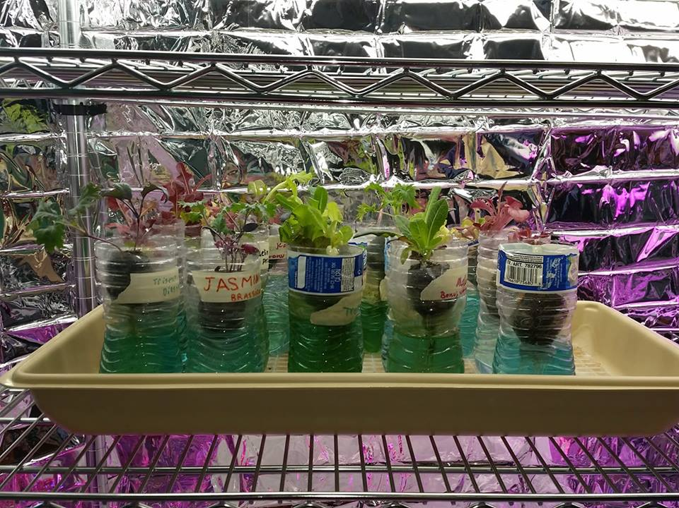
You will need:
- 16 ounce water bottle or 2 liter soda bottle.
- Heavy-duty Scissors
- Duct or Masking Tape
- Cotton wick material such as yarn, kite string, etc. about 16 inches per bottle. .
- Lettuce or Basil starts, plant cuttings, or seeds
- Hydroponic clay balls media, perlite or other porous grow medium.
- hydroponic specific nutrients
- Water
- Hand Drill or Power Drill.
- Wood block for drilling hole in cap

Directions
1) Choose a bottle. Remove the label if necessary.
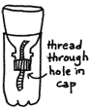
2) Using the drill, make a hole in the cap. Make sure to do this on the piece of wood that is provided. Return to the top of the bottle.
3) Cut the wicking material to 16”. Thread the wicking material through the hole so that half of the wick is on each side of the cap.
4) Cut the bottle a little below the spot where the top of the bottle stops curving using scissors. You can cover the cut edges on the outside with duct or masking tape. That will also help keep the top from slipping down into the bottle. Leave the cap on the top.
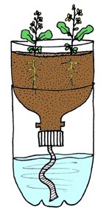
5) Add nutrient water to the bottom of the bottle.
6) Invert the bottle top and fill with clay balls (weaving the wick material through the media.) Make sure the wick material is hanging into the solution.
7) Place plants or seeds in small portions of rockwool in the media.
8) Place bottles in a sunny window or under a grow light.

Passive hydroponics, semi-hydroponics or passive sub-irrigation is a method of growing plants without soil, peat moss, or bark. Instead, an inert porous medium transports water and fertilizer to the roots by capillary action. Water and fertilizer are held in a reservoir and conducted to the roots as necessary, reducing labor and providing a constant supply of water to the roots. In the simplest method, the pot sits in a shallow solution of fertilizer and water or on a capillary mat saturated with nutrient solution. Since routine maintenance is much simplified, passive hydroponics can reduce the labor required to maintain a large collection of plants.
The various hydroponic media available contain more air space than more traditional potting mixes, delivering increased oxygen to the roots. Passive hydroponics also may add additional ambient humidity through evaporation.

